 | CFAS Enterprises Inc.  After Market Utility Power Equipment Brokerage  Mailto:Staff@CFASPower.com  Turbine URL: http://CFASPower.com/Inventory.html  Reciprocating URL: http://CFASPower.com/Recips.html
GTG_1364VS_SiemenGenEnd.doc

1 x New Siemens 2800W 50Hz 6300V Genend

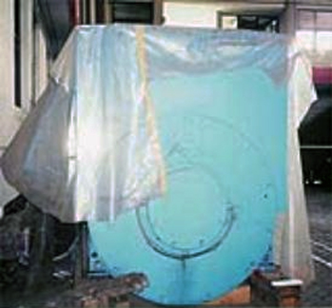

Price: $150,000.00

Year: 1993
Manufacturer: Siemens
Model: IFC L/211/6hc62/z
KW: 2800/3500 Kva
Hz: 50
Power Factor: .8
Voltage: 6300
RPM: 1000
Hours: 0 Since New

