 | CFAS Enterprises Inc.  After Market Utility Power Equipment Brokerage  Mailto:Staff@CFASPower.com  Turbine URL: http://CFASPower.com/Index.html  Reciprocating URL: http://CFASPower.com/Recips.html
GTG_1358IMS_Ruston_Mobiles.doc

3 x Refurbished Ruston Nomad 3.5MW 4,490KVA 50Hz 11KV Mobile Power Station

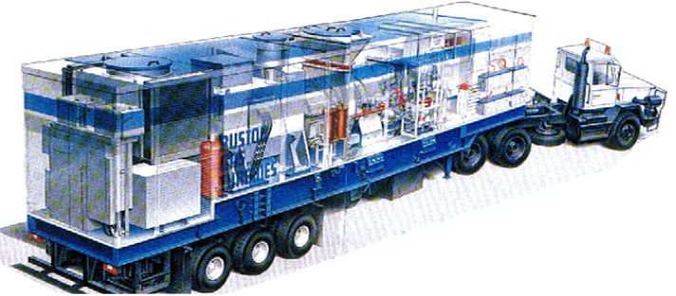

Year of manufacture is estimated at 1992 – 93.
There are three units, subject to prior sale, with running hours and starts of: -
The units will be fully overhauled prior to sale and will be overhauled and tested prior to sale, with full warranty for 12 months.

As above. Three Refurbished Nomad Mobile Generating Unit, plus one spare TB5000 Gas Generator is: £ 3MM ex-works

Budgetary Clause

The information in this document is provided for budgetary reasons only, and is given in good faith and to the best of the knowledge and belief of the Contractor. No warranty or representation is given concerning such information which must not be taken as establishing any contractual offer or other commitment on the part of the Contractor

Refurbished Equipment Clause

Refurbished equipment is tested and supplied to a power rating tolerance of 0 to minus 5% of the original new equipment specification

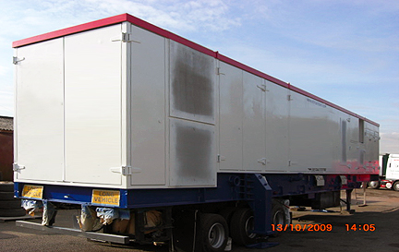

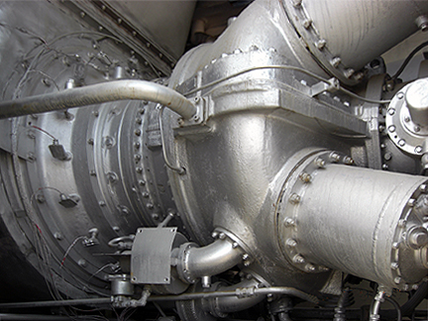

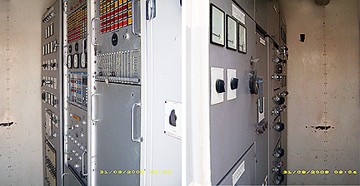

EQUIPMENT OVERVIEW

Total Hours and Starts
Unit 1: 11,728 hours - 1695 Starts
Unit 2: 18,376 hours - 501 Starts
Unit 3: 19,134 hours - 1088 Starts

No. 3 unit has had a major overhaul, however the units have been regularly maintained by the local OEM.

This is a complete, single-trailer power package, capable of generating up to 3.5MW ISO. It can be moved easily and quickly by a standard road tractor unit (NOT supplied), transferred from one location to another as changing circumstances dictate and made (depending on conditions) operational less than 48 hours after arrival on site.

• Proven Reliability
• Dual Fuel Capability
• Black Station Start Capability
• Generator 3.5MW / 4,490 KVA 50Hz, 11KV
• Robust Design Operational in Extreme Climatic Conditions
• Acoustic Treatment

Fuel Consumption
Skid edge fuel gas pressure : 12 barg.
For changeovers - pipe work volume upstream of skid edge stop valve to be, not less than 100 cu.ft.

Fuel consumption: For either fuel, at 5000 ZLHP or 3730 ZLKW, standard conditions, heat input, 48,000,000 Btu/hr.

Units of calorific value assumed to be Btu/st.cu.ft.Listed value of 1013 assumed to be the 'higher calorific value', in which case the 'lower calorific value' used in consumption figures is 930 Btu/st.cu.ft.

Consumption Gas; 12864.Btu/Kw/hr. 13.85 st.cu.ft./Kw/hr. 51610. st.cu.ft./hr.

Oil: lower calorific value,10130 Btu/lb. specific gravity, 0.84
Consumption, Liquid; 1.27lbs./Kw/hr.0.15 galls./Kw/hr.564.galls./hr.

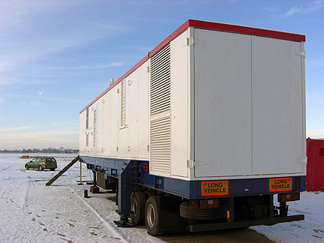

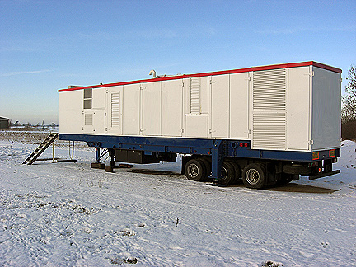

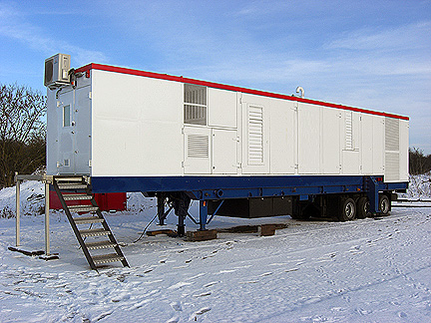

▪ POWER STATION TRAILER EQUIPMENT PLAN COMPRISING

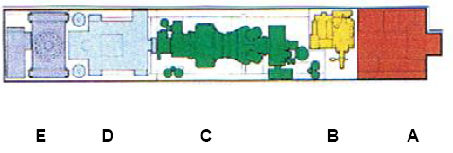

▪ Control Room - A

The air-conditioned control room houses the turbine generator control and protection systems, auxiliary and control batteries, system battery charger, motor control centre and a selectable 415VAC distribution board. Distribution board inputs provide the facility for external customer supply, on board diesel generator supply for “Power Station Black Start Capability” and auto transfer to auxiliary transformer supply derived from on trailer alternator once the turbine driver is running.

▪ Diesel Compartment - B

A 500 litre diesel fuel tank is integral to the trailer chassis Housing Perkins Turbocharged Diesel engine driving hydraulic package for turbine starting and auxiliary power generation to provide power to the on trailer 415VAC distribution board.

▪ Turbine Compartment - C

Housing a TB5000 Model Gas Turbine prime mover, turbine fuel and fluid systems, control devices, instrumentation, turbine lubrication oil tank, and Allen type speed reduction gearbox.

▪ Alternator Compartment - D

Housing GEC-Unipac Alternator rated at 4785kVA, Auxiliary transformer 11KV to 415VAC for trailer internal power distribution,

▪ Cooler and Switchgear Compartment - E

Whipp & Bourne,11Kv generator circuit breaker. HV terminal chamber for connection to customer load. Turbine lubrication system, air blast oil cooler and fire fighting equipment.

▪ ADDITIONAL TECHNICAL AND PERFORMANCE FEATURES MOBILE POWER STATION

TB5000 gas turbine generator set comprises the following:

▪ Turbine Engine Core

Model TB5000 (4900bhp ISO Base Load rating on gas fuel), twin shaft, heavy duty industrial gas turbine, complete with:
• Air inlet casing phased vertically upwards
• Air inlet flexible joint
• Gas generator assembly
• Combustor assembly incorporating 4 combustion chambers
• Power turbine assembly
• Exhaust outlet casing phased vertically upwards
• Exhaust outlet flexible joint

▪ Underbase

• Turbine Trailer underbase of fabricated carbon steel construction, designed for three-point mounting on installation support jacks
• Turbine mounting, allowing thermal expansion towards the non-drive end
• Retractable lifting tubes to facilitate heavy lift handling
• Lubricating oil and auxiliary diesel fuel tanks integral to underbase

▪ Instrumentation

• Air inlet temperature thermocouples
• Exhaust outlet and power turbine exit temperature thermocouples
• Gas generator speed probe
• Power turbine speed probe
• Mechanical over-speed protection trip
•Casing mounted seismic sensor to turbine, gearbox and driven unit

▪ Lubricating Oil System

• Integral lubricating oil system, including all pipework, serving the gas turbine, gearbox and driven unit
• Lubricating oil tank integral to trailer underbase
• Lube oil pressure and temperature transmitters
• Main pump, gearbox-driven
• Auxiliary pump, AC electric motor driven (pre start and post shutdown lubrication)
• Emergency pump, DC electric motor driven (emergency cooling)
• Lubricating oil supply piping in stainless steel downstream of filters
• Duplex filters with manual changeover valve; differential pressure gauge and differential pressure transmitter
• Lubricating oil pressure gauge and transmitter Oil tank temperature transmitter
• Oil tank level gauge
• Oil tank low oil level transmitter

▪ Lubricating Oil Cooler

• Air blast simplex vertical matrix lubricating oil cooler, suitable for high ambient temperature range.

▪ Lubricating Oil Breather

• Breather system internal to Acoustic Enclosure (Including a carbon steel Sand Trap)
• Lube oil breather piping external vent
• Stainless steel flame trap for mounting in the external breather piping

▪ Starting System

• Diesel engine driven hydraulic start system

▪ Ignition System

• High tension igniters (4)
• Fully piped ignition system utilising propane gas fuel supply

▪ Gas Fuel System

• Gas fuel piping in stainless steel
• Gas fuel pressure gauges for fuel valve and burners
• Gas fuel pressure relief valve
• Gas fuel pressure transmitter
• Gas fuel shutoff valve, emergency, rapid acting
• Gas fuel shutoff valve, manually operated
• Gas Fuel Valve

▪ Liquid Fuel System

• Liquid fuel piping in stainless steel
• On trailer Duplex fuel filter permitting on line duty filter replacement
• AC motor driven liquid fuel boost pump, gearbox driven main fuel pump
• Governor-actuated fuel valve
• Solenoid-operated fuel shut-off valve
• Manual emergency shut-off valve
• Burner pressure gauge
• Gas ignition system
• Combustion chamber auto-drain valves

▪ Combustion Air Inlet System

• Standard 2 stage Combustion Air Inlet Filter with particle extraction louvre integral to trailer housing

▪ Combustion Exhaust System

• Flexible joint and transition ducting to enclosure roof

▪ Gearbox and Coupling

• Direct coupled Epicyclic type gearbox of Allen Gear manufacture giving an output shaft speed of 1,500 RPM
• Low maintenance output coupling between gearbox and AC generator

▪ Control System

The control system incorporates the following functions:

• Turbine Sequencing and Protection
• Fault Monitoring
• Annunciation
• Gas Turbine Speed Control
• Temperature Monitoring
• Turbine Casing Vibration Monitoring
• Turbine Gearbox Casing Vibration Monitoring
• Driven Unit Vibration Monitoring
• Driven Unit Bearing Temperature Monitoring
• Control for standard Fire Protection and Gas Detection Monitor
• English language on front panels
• Control Power Supply
• 24V DC and 220/240V AC supply for controls from battery system

▪ AC Generator

• Brushless AC generator, voltage 11kv and frequency to 50Hz, to sound attenuation of 85dba
• Generator cooling type CACA
• Generator bearing temperature detectors
• Class F insulation / F total temperatures
• AC generator lube oil system provided by the gas turbine
• Under base of fabricated steel construction
• Generator alignment jacking screws
• The generator is suitable for a non-hazardous area

▪ Generator Control Panel

• Automatic voltage regulator
• Generator metering equipment
• Generator electrical protection relays
• Automatic and manual synchronising facility with check synch
• Neutral Earth Resistor

▪ Electrical Equipment

• On-package AC and DC interface cabling
• Integral earth protection bonding
• Emergency 'Stop' push-buttons externally mounted on turbine under base
• Local stop push-buttons on turbine AC motors

▪ Batteries

• Nickel-Cadmium batteries are mounted within a carbon steel battery storage cabinet located externally adjacent to control room

▪ Battery Charger

• A simple Erskine battery charger / static inverter is supplied, incorporating a DC-controller to control the turbine DC supply

▪ Acoustic Enclosure

Fitted over the turbine, gearbox and alternator and bolted to turbine under base, for average sound attenuation to 85dB(A) SPL at 1m distance measured at 1.2m above ground level incorporating:
• Internal lighting
• Painted carbon steel construction
• Access Doors provide for personnel maintenance access
• Removable panels for maintenance access
• Acoustic enclosure ventilation inlet damper
• Acoustic enclosure ventilation outlet damper
• Acoustic enclosure ventilation air flow detector
• Acoustic enclosure Ventilation System

▪ Ventilation Filter

• High efficiency cleanable pad type combustion air filter.

▪ Ventilation Fan

• AC electric motor-driven ventilation outlet fan to Zone 1 classification, duct-mounted (Ex 'd' type).

▪ Fire Protection and Gas Detection System

• 2 - ultra-violet flame detectors
• 1 - heat detector
• 3 - gas detectors
• Twin shot CO2 fire protection system
• Extinguishant release audible and visible alarms
• Enclosed rack-mounted CO2 bottles

▪ Turbine Compressor Cleaning System

• Cold turbine compressor wash system
• Mobile wash trolley, incorporating cleaning fluid/rinse tank fitted with integral pressure relief valve, air pressure control solenoid valve, air/ wash fluid flexible hose with quick release connections, and electrical cable
• Drain system incorporating automatic drain valve
• Pressure transmitter to monitor intermediate stage blow-off valves closing air pressure

Exclusions
The Contractor does not accept any responsibility for items which are outside its above scope of supply. Where design of the installation is to be provided by the purchaser The Contractor requests the opportunity to see the general arrangement. It is particularly important for safe and proper operation to ensure that any extra ductwork is compatible with the gas turbine.
The following items are specifically excluded from this Tender:
Strictly all Equipment other than that detailed above (Scope of Supply)
Skilled and unskilled manpower for the installation and commissioning of the generator set
Tractor unit (s)
Civil engineering design of any kind.
Building and civil works.
Site facilities.
Drains and/or vent piping from the gas turbine package to a remote point.
Lubricating oil
Lubricating oil measuring equipment other than that defined in the scope of supply.
Additional lubricating oil breather ducting other than that offered in the scope of supply.
Fuel storage and treatment.
Fuel for the gas turbine.
Fuel supply pipework beyond The Contractors scope of supply.
Propane gas bottle and regulator (for starting)
Off skid Gas fuel block and vent valve assembly
Vibration monitoring equipment other than that offered in the scope of supply
Support hangers for any extra ducting, silencing and pipe-work.
All inlet, exhaust and ventilation ducting other than included in the scope of supply.
Site earthing.
Lightning protection.
Power and load management system other than that offered in the scope of supply.
Power systems study.
Cable trays, cleats and ducts for HV and LV cabling, cabling other than that offered in the scope of supply.
Switchgear, and associated protection other than that offered in the scope of supply.
Sensing and metering voltage transformers other than that offered in the scope of supply.
VT for sensing beyond scope of supply (In the case of close coupled transformer, this will be available at extra cost)
Machine power transformers, and associated protection other than that offered in the scope of supply.
Differential current transformers for close coupled transformers other than that offered in the scope of supply. Grid failure detection equipment. (Client should provide a proprietary loss of grid relay such as ”rate of change of frequency”. ROCOF)
Compressed air supply and off-skid pipework other than that offered in the scope of supply. Acoustic equipment other than that offered in the scope of supply.
External lagging of engine.
Gas fuel demister other than that offered in the scope of supply.
Off-skid electrical cabling, and design of off-skid cable routing.
Off-skid cable tray, and design of off-skid cable tray routing.
Installation of off-skid cabling, cable tray, and design.
MECHANICAL DRIVE PERFORMANCE

Turbine Performance – TB4900

Typical Performance
(Performance based on 100% load, 0ft, 99.0% gearbox efficiency)

Performance
Ambient Temp | ºC | 0 | 5 |  | 10 | 15 | 20 |  | 25 |  | 30 | 35 |  | 40 | 45
Power Turbine Speed | % | 100 | 100 |  | 100 | 100 | 100 |  | 100 |  | 100 | 100 |  | 100 | 100
Requested Load | % | 100 | 100 |  | 100 | 100 | 100 |  | 100 |  | 100 | 100 |  | 100 | 100
Inlet Depression | ^{mm H20} | 75 | 75 |  | 75 | 75 | 75 |  | 75 |  | 75 | 75 |  | 75 | 75
Exhaust Depression | ^{mm H20} | 100 | 100 |  | 100 | 100 | 100 |  | 100 |  | 100 | 100 |  | 100 | 100
Driven Unit Output | ^{BHP} | 5159 | 5035 |  | 4857 | 4676 | 4503 |  | 4325 |  | 4148 | 3971 |  | 3794 | 3617
Heat Input | ^{kW} | 15225 | 14989 |  | 14637 | 14276 | 13930 |  | 13577 |  | 13223 | 12869 |  | 12515 | 12160
Exhaust Mass Flow | ^{kg/s} | 21.82 | 21.46 |  | 21.05 | 20.64 | 20.22 |  | 19.80 |  | 19.38 | 18.96 |  | 18.53 | 18.11
Exhaust Temperature | ºC | 471 | 478 |  | 484 | 489 | 494 |  | 499 |  | 504 | 509 |  | 514 | 519

