 | CFAS Enterprises Inc.  After Market Utility Power Equipment Brokerage  Mailto:Staff@CFASPower.com  Turbine URL: http://CFASPower.com/Index.html  Reciprocating URL: http://CFASPower.com/Recips.html
GTG_1332PE_Althom6541.doc

2 x Alstom PG6541B 35MW Each 50Hz Combined Cycle Power Plant

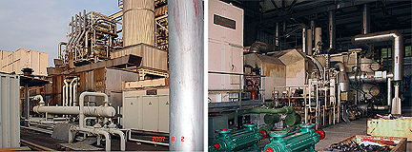

Description: 2 x Alsthom PG6541-B Gas Turbine Gensets - Manufactured in 1991/installed 1993. 35MW each @ 50Hz. Operating hours 28524/31267. Last pre OH maintenance was conducted in 2000. Includes HRSG built by Stein. Located in China.

Asking Price: USD $9.765MM Both
Steam Turbine And Main Transformer NOT Include

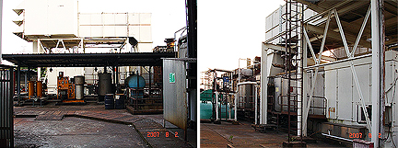

Manufactured by France EGT—ALSTHOM
Model PG6541-B
Manufactured Date End Of 1991
Operation Date March 1993
Total Running Hours 1#GT 28524hours
2#GT 31267hours
Last OH: Both Units were OH by GE Singapore in July,2004
TSO: 2000 hrs
Operation Mode Single Or Combined Cycle
Rotation Direction Look From Control Cabin To Generator- Clockwise
Fuel Type Light Diesel Or Heavy Fuel Oil
Start Up Method Diesel Engine Start Up
Basic Protection Micro Computer Protection
Cooling Water Mode Internal Circulation
Rated Output Power 35MW
Inlet Temp Ambient Temp
Exhaust Temp 527 544
Turbine Inlet Temp 1074 1104
Inlet Air Pressure Drop 125mmh2o 1.2258kpa
Exhaust Pressure Drop
Simple Cycle 75 Mmh2o
Combined Cycle 300 Mmh2o

Heat Rate
Simple Cycle 11935 11716KJ/KWH
Combined Cycle 8044 7914KJ/KWH

Heat Consumption Simple Cycle 402.2×106KJ/H 417.7×106KJ/H
Efficiency Simple Cycle 30.16% 30.73
Combined Cycle 44.75% 45.49%
Air Flow 138.3kg/S(100%Speed ISO)
Compressor Stages 17stages
IGV Mode Hydraulic Adjustable
Inlet Pressure 1013mbar
Compressor Mode Axial Flow
Compressor Ratio 11.8
Compressor Speed 5114rpm
Turbine Mode Single Axial Axial Flow
Turbine Stages 3 stages
Turbine Speed 5114rpm
Generator Manufacturer Alsthom
Generator Model T190-240
Generator Output Voltage 11kv
Generator Frequency 50hz
Excitor Model ,Power Tkj70-10 126.5kw
Generator Output Power 37.1mw
Start Up Engine Model Power 12v71t、630hp
Start Up Drive Clutch
Torque Converter Hydraulic Torque Converter
Electro-Hydraulic Rotator
Auxiliaries Gear Box Model AA51DA
Load Gear Box Input Speed: 5114 rpm
Output Speed 3000 rpm
Turbine control MARK
HRSG brand France STEIN
HRSG type: Vertical Non-Duct Heating Dual Pressure Force Circulation
HRSG Flowrate: 10.363.6t/H
Steam Pressure: 53×105pag
Steam Temp 492
Last Maintenance date: July 2000

