 | CFAS Enterprises Inc.  After Market Utility Power Equipment Brokerage  Mailto:Staff@CFASPower.com  Turbine URL: http://CFASPower.com/Index.html  Reciprocating URL: http://CFASPower.com/Recips.html
GTG_1325GR_6541ME50Hz.doc

2 x Rebuilt GE PG 6541-B 39.5MW 50Hz Dual Fuel Gas Turbine Generator

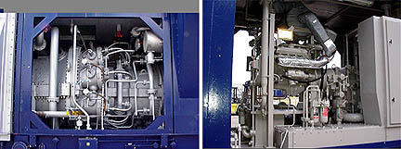

NOTE: Unit (S) Are Subject To Prior Sale Without Notice.

Asking Price: USD $16MM each
Middle East Trade Zone with one (1) year , 8,000 hour warranty
Complete BOP included

Unit No 1.: PG 6541B
YOM: 1992
Total hours since new: 23,000 hours
OEM: General Electric

Unit No 2.: PG 6541B
YOM: 1992
Total hours since new: 23,000 hours
OEM: General Electric

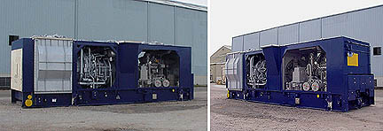

Fuel: Liquid/Gas Fired
Rating: ISO rated @ 39.5MW: (Gas fired )
Voltage: 11.5Kv
Phase: 3
Frequency: 50 Hz-
pf : 0.8
Units can also be upgraded to 41 MW

GAS TURBINE – 2 x FRAME 6B

GAS TURBINE:

Manufacturer: Alsthom
Qty: One
Condition: Refurbished
Year Manufactured: 1990
Serial No.: T650
Capacity ISO: 38340 KW
Cycle: Open
Fuel Type: Gas/Distillate
Starting Device: Diesel Engine
Scope Genset and Auxiliaries
Zero Hours: 0
Control System Type: Sentinet PLC + Gem Controls + MCC
Batteries/Charger

Generator Manufacturer: Alsthom
Type: 412707
Serial # 412707
Nominal Voltage: 11000V
Frequency: 50 Hz
MVA: 47.00
Exciter: Rotating Diode
Cooling: Filtered Air

Additional Information:

Availability Date: Immediate
Auxiliary Equipment: Yes
Location: Dubai, U.A.E.
Prior To Refurbishment
Hours Run: 28,684
Starts: 2,260

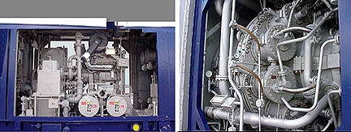

Frame 6B 37 MW ISO GTG 50 Hz.

Gas Turbine

Manufacturer: John Brown Engineering
Qty: One
Year Manufactured: 1990
Serial # 295511
Model # MS6541B
Capacity ISO: 38340 KW
Cycle: Open
Fuel Type: Gas/Distillate
Starting Device: Diesel Engine
Scope: Genset and Auxiliaries
Zero Hours: 0
Control System Type: Sentinet PLC + Gen Controls+ MCC+
Batteries / Charger
Generator Manufacturer: John Brown Engineering
Type: BDAX 7-225 ER ( Brush)
Serial # 3139426
Nominal Voltage: 11000V
Frequency: 50 Hz
MVA: 47.00
Exciter: Rotating Diode
Cooling: Filtered Air
Additional Information
Availability Date: Immediate
Auxiliary Equipment: Yes
Location: Dubai, U.A.E.
Prior To Refurbishment
Hours Run 22,168
Starts: 2,861

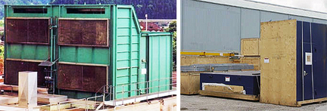

1.0 Scope of Supply

  - Gas turbine & auxiliaries

Gas turbine Frame 6B complete with the auxiliaries:

- 17 Stage, axial flow, heavy duty compressor with variable guide vanes

- 10 Combustors of reverse flow design each with - 1 fuel nozzle, 2 spark plugs

- 4 UV type flame detectors

- 2 Stage power turbine with horizontal split casing

Accessory gear box

Load, accessory and generator couplings

On base lube oil system

2x100% lube oil coolers

Accessory gear shaft driven gear type main lube oil pump

415/480 volts AC motor driven aux. oil pump

DC motor driven emergency centrifugal oil pump

Lube oil tank with heater

2x100% oil filters

Lube oil piping complete - pipes, flanges, hardware : (SS piping after filter)

GTG drain oil piping - pipes, flanges, hardware

2x100% oil de-mister fans & motors

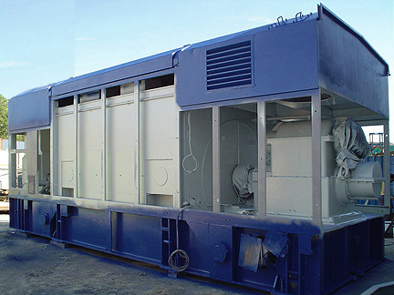

By-pass valves , re-circulation valves, piping sections, fittings & hardware, local pressure gauges ,Return pipes

Control & protection system

Shaft driven hydraulic oil Pump

Cables for interconnection between control panel & GT junction boxes

Control & hydraulic oil piping with flanges and hardware in stainless steel

N2 Pressure accumulator in hydraulic oil circuit

Fuel system

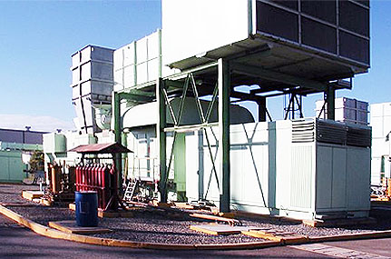

Single mechanical flow divider

Safety shutdown valve (fuel pressure to open)

Emergency stop valve

LP fuel filter, on-line filling line, drain Lines, DP gauge and DP switch, drain lines

Fuel changeover 3-way valve

HP filter after fuel injection pump

Fuel control valve

Interconnecting piping, fittings, flanges and coupling & hardware

Fire detection & CO2 system for the skid/container

Standard fuel piping, fittings, strainers, safety shutdown, venting and gas distribution arrangement

Liquid fuel safety shutdown - quick shutdown valves, solenoid valves, pressure switches

Atomizing air system

Shaft driven Atomizing Air compressor

Starting compressor driven by diesel engine

Atomizing air cooler

Drainage system

Drain piping complete with isolation valves for water including off-line compressor wash water flow.

Drain piping complete with isolation valves for oil (lube oil/diesel engine fuel and GT fuel)

Air inlet system with filtration system

Support structure, panel walls, bracing, structural supporting columns, rain hood, ladders, gratings, hand railings,

Ladder & platform, lifting devices, filter house panels, tube sheets

Cylindrical & cellulose filter elements

Clean air plenum

Control panel, cables, terminal box

PI and PT, TI and TE at compressor inlet, DPG and DPS across the filter assembly

Mist separator

Access doors, internal lighting

Hardware for filters- element support yokes, retention nuts, washers, gaskets

Hardware for foundation- foundation bolts, washers, gaskets & shims

Connecting hardware - nuts, bolts, washers, gaskets

Air inlet duct with silencer & structural support including expansion joints

Exhaust gas system

Expansion joint with a mating flange, bolts, nuts

Distance piece between expansion joint & gas turbine exhaust flange

Gas turbine acoustic enclosure

Steel frames

Walkways/staircase components viz. support ladders, chequered plates, gratings, handrails, chain hoists

Roofs

Fixing hardware - bolts, nuts, gaskets, washers, door locks, chains, hinges

Ventilation system for all containers (naphtha container, GTG enclosure and load gear compartment & CO2 container etc.)

Fire protection system (includes generator exciter protection) as per NFPA 12A

Load cell mounted 25 nos. CO2 cylinders with piping etc. in a container

Spray nozzles, distribution piping & control system, fittings

Break switches for CO2 release

Heat detector type fire detectors in each compartment/ zone

GT starting system

Diesel engine including fuel supply/ injection system, cooling system, piping spools, interconnecting piping with all fittings, flanges hardware, exhaust silencer

Valves for various services like water, fuel, lube oil etc.

Miscellaneous piping, hardware, fittings (valves, flanges)

Generator (air to water cooled) and auxiliaries

Brush-less excitation System

General phase & neutral side CTS (for protection, metering & AVR)

Generator PT (for protection, metering & AVR)

Generator instrumentation, control & synchronizing panel

AVR

AVR manual channel

Generator protective relays

Central protection unit

87G-generator differential

51V-overcurrent volt restraint

50-instantaneous over-current

59G-over voltage

51N-neutral over-current – 95%

64G-stator earth fault – 90%

46-negative phase sequence

40-loss of excitation

32-reverse power

37- low forward power

81-frequency, 2-stage

60-voltage balance relay

27-under voltage

86G-generator lockout relay

Block differential protection - KBCH130 relay (numerical type) consisting of

24- volt/hertz relay

87B- generator, generator transformer and unit auxiliary transformer differential

Other protections not configured in LGPG111 and KBCH130

76- excitation over-current

60EX- excitation voltage balance

60AVR- AVR power supply fault

49G- stator over temperature

49NGT- NGT over-temperature

49ET-excitation transformer over temperature

64R- rotor Earth fault

21G- back-up impedance relay

25- synchro-check relay

Generator neutral side CTS

Generator neutral side to neutral cubicle connections

Load gear box complete

Control & instrumentation System

Speedtronic MARK-V control package with following features:

Turbine control panel

Generator control & protection panel

Generator excitation panel

Fire protection panel

Gas detection panel

125V DC Ni-Cd batteries and battery charger

415Volts MCC (2 In-comers) for GTG auxiliaries (short circuit capacity 50 kA)

DCDB

Standard accessories for the above :

- Air conditioning unit, integral cables, connectors, junction
boxes, terminals

- Mounting racks, supporting hardware

- UPS

Operator work station in GT control package

