 | CFAS Enterprises Inc.  After Market Utility Power Equipment Brokerage  Mailto:Staff@CFASPower.com  Turbine URL: http://CFASPower.com/Index.html  Reciprocating URL: http://CFASPower.com/Recips.html
GTG_1324GR_6541US50Hz.doc

1 x Rebuilt GE PG 6541-B 36.MW 50Hz Dual Fuel Gas Turbine Generator

1 x Rebuilt GE PG 6571-B 40MW 50Hz Dual Fuel Gas Turbine Generator

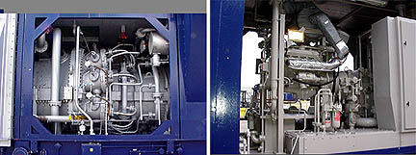

NOTE: Unit (S) Are Subject To Prior Sale Without Notice.

Asking Price: USD $12.95MM each
FAS USA Port with one (1) year , 8,000 hour warranty
Complete BOP included

Unit No 1.: PG 6541B
YOM: 1992
Total hours since new: 125,000 hours
OEM: General Electric

Unit No 2.: PG 6571B
YOM: 1992
Total hours since new: 125,000 hours
OEM: General Electric

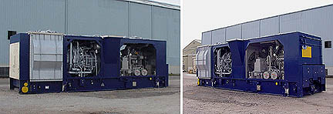

Fuel: Liquid/Gas Fired
Rating: ISO rated @ 39.5MW: (Gas fired )
Voltage: 11.5Kv
Phase: 3
Frequency: 50 Hz-
pf : 0.8

UNIT PERFORMANCE

9. performance

9.1 The performance of the fully serviced and “0” houred Gas turbine is as follows:

OPTION 1: Frame 6571:

Output & Heat rate at ISO conditions of 15 Degs. C and 1013mBars (Sea Level)

FUEL (LHV) | OUTPUT (kWs) | Heat Rate (Btu/ Kwhr)
GAS | 40,700 | 10,645
DISTILLATE | 40,000 | 10,700

N.B. Water injection will increase the output figures by approximately 8%.

OPTION 2: Frame 6541:

Output & Heat rate at ISO conditions of 15 Degs. C and 1013mBars (Sea Level)

FUEL (LHV) | OUTPUT (kWs) | Heat Rate (Btu/ Kwhr)
GAS | 37,000 | 11,078
DISTILLATE | 36,000 | 11,189

These performance figures will be obtained when the following operating/ambient conditions apply:

Gas Turbine Unit : PG 6571 / 6541
Ambient Temperature : 15°C
Atmospheric Pressure : 1013 mbar (a)
Humidity : 60%
Inlet Duct Losses : 4 inches WG
Exhaust Duct Losses : 2 inches WG
Fuel : Natural Gas / Distillate to OEM Specification.

9.2 This performance is subject to the following:

(i) Each test to establish the performance figures shall be made when:
(a) The gas turbine is commissioned and is in a clean and in proper working condition.
(b) Using a fuel of an acceptable quality as specified above.
(c) Distillate fuel inlet pressure to the on base liquid fuel flange of 40 to 55 psig.
(d) The contractor is witness to the test.

(ii) The tests, procedure and method of measurement (including margins to cover errors in observation and measurement) to establish the operating specifications shall be mutually agreed before commencement of the tests. Prior to commencing the actual testing the main contractor will provide specific customised data sheets for recording the unit parameters.

(iii) Method of measurement of ambient air temperature and ambient pressure shall be agreed.

- All performance tests shall, unless otherwise agreed, be carried out immediately following the date that the gas turbine is ready for such tests.

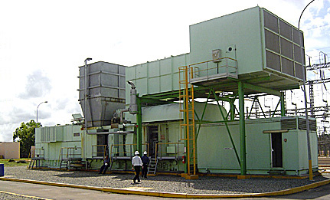

1.0 Scope of Supply

  - Gas turbine & auxiliaries

Gas turbine Frame 6B complete with the auxiliaries:

- 17 Stage, axial flow, heavy duty compressor with variable
guide vanes

- 10 Combustors of reverse flow design each with - 1 fuel
nozzle, 2 spark plugs

- 4 UV type flame detectors

- 2 Stage power turbine with horizontal split casing

Accessory gear box

Load, accessory and generator couplings

On base lube oil system

2x100% lube oil coolers

Accessory gear shaft driven gear type main lube oil pump

415/480 volts AC motor driven aux. oil pump

DC motor driven emergency centrifugal oil pump

Lube oil tank with heater

2x100% oil filters

Lube oil piping complete - pipes, flanges, hardware : (SS
piping after filter)

GTG drain oil piping - pipes, flanges, hardware

2x100% oil de-mister fans & motors

By-pass valves , re-circulation valves, piping sections,
fittings & hardware, local pressure gauges ,Return pipes

Control & protection system

Shaft driven hydraulic oil Pump

Cables for interconnection between control panel & GT junction
boxes

Control & hydraulic oil piping with flanges and hardware in
stainless steel

N2 Pressure accumulator in hydraulic oil circuit

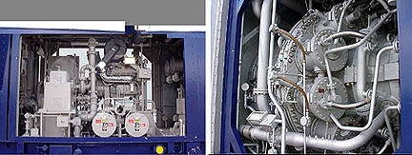

Fuel system

Single mechanical flow divider

Safety shutdown valve (fuel pressure to open)

Emergency stop valve

LP fuel filter, on-line filling line, drain Lines, DP gauge and
DP switch, drain lines

Fuel changeover 3-way valve

HP filter after fuel injection pump

Fuel control valve

Interconnecting piping, fittings, flanges and coupling &
hardware

Fire detection & CO2 system for the skid/container

Standard fuel piping, fittings, strainers, safety shutdown,
venting and gas distribution arrangement

Liquid fuel safety shutdown - quick shutdown valves, solenoid
valves, pressure switches

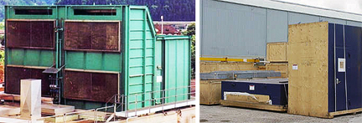

Atomizing air system

Shaft driven Atomizing Air compressor

Starting compressor driven by diesel engine

Atomizing air cooler

Drainage system

Drain piping complete with isolation valves for water including
off-line compressor wash water flow.

Drain piping complete with isolation valves for oil (lube
oil/diesel engine fuel and GT fuel)

Air inlet system with filtration system

Support structure, panel walls, bracing, structural supporting
columns, rain hood, ladders, gratings, hand railings,

Ladder & platform, lifting devices, filter house panels, tube
sheets

Cylindrical & cellulose filter elements

Clean air plenum

Control panel, cables, terminal box

PI and PT, TI and TE at compressor inlet, DPG and DPS across
the filter assembly

Mist separator

Access doors, internal lighting

Hardware for filters- element support yokes, retention nuts,
washers, gaskets

Hardware for foundation- foundation bolts, washers, gaskets &
Shims

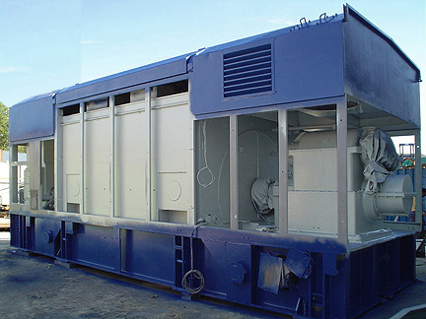

Connecting hardware - nuts, bolts, washers, gaskets

Air inlet duct with silencer & structural support including
expansion joints

Exhaust gas system

Expansion joint with a mating flange, bolts, nuts

Distance piece between expansion joint & gas turbine exhaust
flange

Gas turbine acoustic enclosure

Steel frames

Walkways/staircase components viz. support ladders, chequered
plates, gratings, handrails, chain hoists

Roofs

Fixing hardware - bolts, nuts, gaskets, washers, door locks,
chains, hinges

Ventilation system for all containers (naphtha container, GTG
enclosure and load gear compartment & CO2 container etc.)

Fire protection system (includes generator exciter protection)
as per NFPA 12A

Load cell mounted 25 nos. CO2 cylinders with piping etc. in a
container

Spray nozzles, distribution piping & control system, fittings

Break switches for CO2 release

Heat detector type fire detectors in each compartment/ zone

GT starting system

Diesel engine including fuel supply/ injection system, cooling
system, piping spools, interconnecting piping with all fittings,
flanges hardware, exhaust silencer

Valves for various services like water, fuel, lube oil etc.

Miscellaneous piping, hardware, fittings (valves, flanges)

Generator (air to water cooled) and auxiliaries

Brush-less excitation System

General phase & neutral side CTS (for protection, metering &
AVR)

Generator PT (for protection, metering & AVR)

Generator instrumentation, control & synchronizing panel

AVR

AVR manual channel

Generator protective relays

Central protection unit

87G-generator differential

51V-overcurrent volt restraint

50-instantaneous over-current

59G-over voltage

51N-neutral over-current – 95%

64G-stator earth fault – 90%

46-negative phase sequence

40-loss of excitation

32-reverse power

37- low forward power

81-frequency, 2-stage

60-voltage balance relay

27-under voltage

86G-generator lockout relay

Block differential protection - KBCH130 relay (numerical type)
consisting of

24- volt/hertz relay

87B- generator, generator transformer and unit auxiliary
transformer differential

Other protections not configured in LGPG111 and KBCH130

76- excitation over-current

60EX- excitation voltage balance

60AVR- AVR power supply fault

49G- stator over temperature

49NGT- NGT over-temperature

49ET-excitation transformer over temperature

64R- rotor Earth fault

21G- back-up impedance relay

25- synchro-check relay

Generator neutral side CTS

Generator neutral side to neutral cubicle connections

Load gear box complete

Control & instrumentation System

Speedtronic MARK-V control package with following features:

Turbine control panel

Generator control & protection panel

Generator excitation panel

Fire protection panel

Gas detection panel

125V DC Ni-Cd batteries and battery charger

415Volts MCC (2 In-comers) for GTG auxiliaries (short circuit
capacity 50 kA)

DCDB

Standard accessories for the above :

- Air conditioning unit, integral cables, connectors, junction
boxes, terminals

- Mounting racks, supporting hardware

- UPS

Operator work station in GT control package

