 | CFAS Enterprises Inc.  After Market Utility Power Equipment Brokerage  Mailto:Staff@CFASPower.com  Turbine URL: http://CFASPower.com/Inventory.html  Reciprocating URL: http://CFASPower.com/Recips.html
GTG_1316JL_GELM5000.doc

1 X Usd GE LM5000STIG 47MW/11Kv/50hz/ Gas Turbine Plant

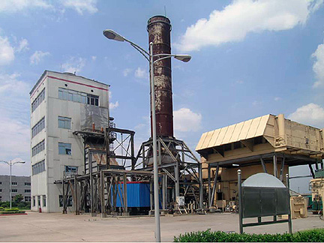

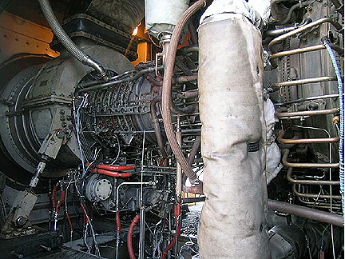

Price: USD $3MM Removed and Packed

The Scope Of Supply Includes GTG, HRSG, Main Transformer And All Auxiliary Equipment.

The Serial Number For The GT: GE7LM5000-GE-NDBG-G03 Is SN474-142
Generator Model: Brush BDAX7-290ER
HRSG: Deltak DINO4530 HRSG
Main Transformer Model: SF8-63000
Rating: 110,63000 kva
Connection: YN.D11
Voltage: 121x2.5%/11.5kv
Current: 300.6/3163A
Frequency: 50Hz
Cooling: Natural Cooling/Fan

The Steam Generated By The HRSG Is Injected Into The Gas Turbine (STIG) , Therefore, There Is No Steam Turbine.

The Control System Has Converted From Woodward DCS 501 Into Siemens PCS7
Major Overhaul Is Done By MTU.

Used Gas Turbine LM5000STIG

Manufacturer: GE Stewart & Stevenson
Model: LM5000STIG
Year Of Manufacture: 1990
Total Running Hour: 28780
Fuel: Light Diesel
Ambient Temp: 15 C
Atmospheric Pressure: 101.325kpa
R.H. L 60%
Generator Output Voltage: 11.5kv
Power: Factor:0.9
Frequency: 50Hz
Speed: 3000 rpm
Inlet Pressure Loss: 4 In H₂O
Outlet Pressure Loss: Single Cycle 8 In H₂O STIG 10 In H₂O
Single Cycle Output Power: 31427kw
Heat Rate: 1O3O5BTU/kWH
STIG Power Output: 47020kw
Heat Rate: 8660 BTU/kWH
Noise Level: 90dB (A) At 1m From Cabin,1.5m Height From Platform

- Gas TurbineManufacturer: G.E. USA

Combustion System: GE7LMS000-GE-NDBG-G05 474-142
Low Pressure Compressor: 5 Stages
Ratio: 2.5
High Pressure Compressor: 14 Stages
Ratio: 12
Combustion Chamber: Ring Type 30 Fuel Nozzles
High Pressure Turbine: 2 Stages
Low Pressure Turbine: 1 Stage
Low Pressure Rotor Speed: Max. 4325 rpm
High Pressure Rotor Speed: Max.10800 rpm

- Power Turbine

- Model: GET-5000-GO3
- No Of Stage: 3
- Speed: 3000 rpm

3. Lub Oil Supply Pressure: 20-85 psig

4. Lub Oil Return Pressure: 15-75 psig

5. Start Up System: Hydraulic Speed Converters

6. AC Generator: Brush Electric Machines Ltd

Model: 1 Class. D,Partll
Rate Power 52244kva
Power Factor: 0.9
Output Voltage: 11.5kv
Frequency: 50hz
Phase: 3
Connection: Star
Speed: 3000 rpm
Cooling: Air Cooled

7. GT External Lub Oil System

Oil Tank Cap: 200 Gal (832.7 lit)
Lube Oil Filter Spec: 6 micron
Lube Oil Return Spec: 6 micron
Cooling System: Dual Air/Oil Cooler
Lib Oil Spec: MIL-L-23699 Or MIL-L-7808

8. Generator Lube Oil System

Oil Tank Cap: 500 gal (1 892.5 lit)
Filter Spec: 6
MicronCooling System: Dual Gas/Oil Cooler
Oil Supply: Generator Drive Oil Pump, AC Oil Pump And High Level Oil Tank
9. Fuel System

Filter Spec: 19 micron
Supply Pressure: 10-15OºPSIG
Oil Temp Max: 150º F(65.5º C0
Supply Cap: 65 gal/min(246 lit/min)
Fuel Oil Spec: Light Diesel To GE Standard

10. Steam Return System
High Pressure Steam Flow: Approx. 72000 lb/hr
Low Pressure Steam Flow: Approx. 72000 lb./hr

11. Off Line Washing System
Water Pressure: 15-65 psig
Water Tank Cap: 25 gal (94.63 lit)
Meter Air Pressure: 85-120 psig)

12. Hydraulic Start Up System
Oil Tank Cap: 40 gal (151.4 Lit)
Oil Filter Spec: 10 Micron
Oil Pump Cap: 20 gal/min (340 PSIG)
Circular Pump Cap: Max. 56 gal/min(5200 psig)
Start Up Motor Cap: Variable Cap.0-6.53
CIDHydraulic Oil Spec: MIL-H- 1767212075TH

13. Ventilation System
Total Air Flow: 373000 cu. ft./min (10444 cbm/min)
GT Inlet: 275000 cu. ft./min (7700 cbm/min)

Air Flow To GT Cabin: 1 Fan 60000 cu. ft./min (1680 cbm/min)
2 Fans 12000 cu./ft../min (3360 cbm/min)
Air Flow To Generator Cabin: 1 Fan 38000cu.ft./min(1064 cbm/min)
2 Fans 76000 cu. ft./min(2128 cbm/min)

14. Total Dimension
Total Length 80ft. In( 24.32m)
Width
Main Cabin: 13ft. 6in (4.104m)
Including Air Filter And Rain Sheath: 46ft. 9In (14.212m)
Total HeightMain Cabin: 14ft. 6In (4.408m)
Include Air Filter Housing: 36ft. (11m)

