 | CFAS Enterprises Inc.  After Market Utility Power Equipment Brokerage  Mailto:Staff@CFASPower.com  Turbine URL: http://CFASPower.com/Index.html  Reciprocating URL: http://CFASPower.com/Recips.html
GTG_513EM_GEC610c_50HZ.doc

Two General Electric Company
Model EM610 Gas Turbine Generator Sets

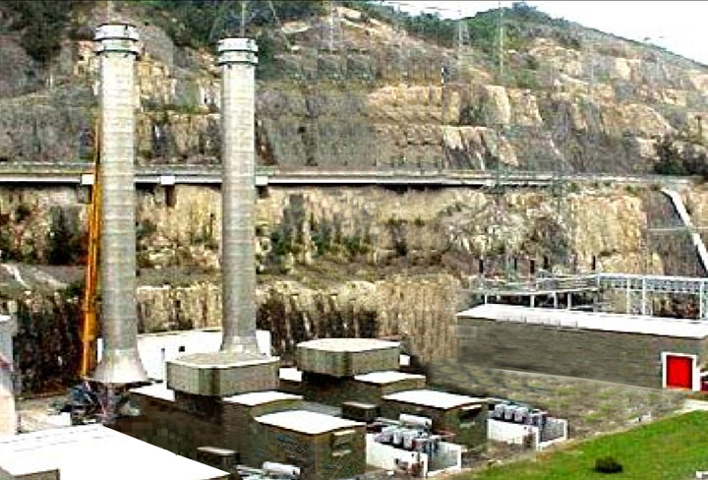

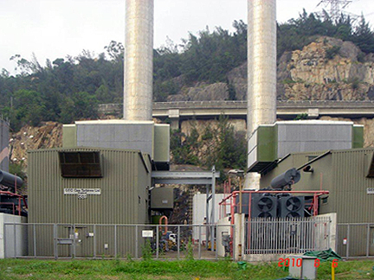

Two (2) GEC 66.9 MW Gas Turbines, Base load 61.7 MW, 3000 rpm, 50 HZ, 11.8 KV, Fuel: diesel fuel, Manufactured in the UK in 1981, Used for peak load, Hours of operation since new 458 hrs and 602 hrs. Can be upgraded to operate on Dual Fuel ( Natural Gas and Diesel Fuel).

Asking Price US $5.2MM Both
Completely disassembled and packed in containers ready to ship. Must be removed from site immediately

50hz/11.8kv
61.7mw Base Load, 66.9mw Peak Load
Length Width Height Weight
Gas Turbine 19Ft 13ft 15ft 123ton
Generator 26Ft 11ft 12ft 125ton
Two Operational Gec E6110c 50hz Gas Turbine Generator Sets With:

- 1 Each Pratt & Whitney GG3 and GG4 Gas Turbine Generators
- 13 Stage Compressor And 2 Stage Power Turbine, Single Shaft Supported By 2 Bearings
- 3 X 3.3 Kv Motor Starter And 1 X Diesel Engine Starter
- 2 Pole, 3 Phase 50hz 11.8 Kv 79.4 Ma Air Cooled Generator
- Brussels Exciter Control System
- 11.8/132 Kv 80 Ma Ofaf Generator Transformer With On Load Tap Changer
- 11.8/433v 240kva Onan United Transformer
- 110v Ac Inverter W/Battery/Charger System
- High Scanning Speed Temperature Monitoring System With Ibm Pc Data Acquisition Program
- Full Package Of Aux.’S
- With 2 Diesel Storage Tanks And 1 Lpg Storage Plant As Options.

History

- The Two Model Em610c Gas Turbine Set, Manufactured By Gec Gas Turbines Limited And Commissioned In 1981.

- They Are Designated Cg1,Cg2,Cg3 And Cg4. With The Exception Of Cg2 (Which Has Been Maintained Fully Operational For Black-Start Capability) The Units Are Available For Service Through Until 1998 When They Became Surplus To Generation Requirements In The System.

- Cg1, Cg3 And Cg3 Are Currently Under Preservation And Cg2 Remains As A Black Start Auxiliary.

- The Operating Hours/Starts For Cg1-Cg4 Are 598/661, 529/665. 604/665, And 460/646 Respectively.

Design Data

- Base Load 61.7mw And Peak Load 66.9mw Under Ambient Air Conditions Of 30 Degrees And 1013mar
- Corresponding Thermal Efficiencies For Base Load And Peak Load At 26.7% And 27.2%
- Normal Start/Quick Start To Base Load Total Time Required At 13.5 Min And 7.5 Min.
- Normal Start/Quick Start To Peak Load Total Time Required At 15.5 Min And 10 Min.

Gas Turbine

- Single Shaft, 2 Bearing Supported On Rigid Steel Stools
- 13 Compressor Stage, 2 Power Turbine Stage
- 10 Individual Reverse Flow Combustion Chambers
- Designed To Run On Liquid Fuel
- Mean Gas Temperature At First Row Guide Vanes 970 Degrees C Base/1015 Degrees C Peak
- Mean Gas Temperature At Turbine Exhaust At 532 Degrees C Base /572 Degrees Peak

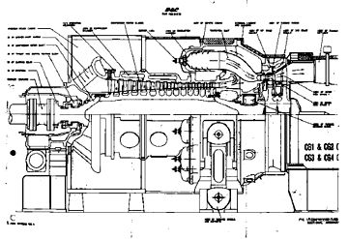

Fuel Specification

- Industrial Diesel Oil
- Minimum Calorific Value At 45579 Kj/Kg
- Minimum Kinematic Viscosity 1.6 C’s

Fuel Oil System

- One Fuel Oil Forwarding Skid Comprises Of 6 Ac Pumps; And One Dc Pump For Blackstart
- 2 Staged Filtration And Pumping At Gas Turbine Side
- Hydraulically Control Fuel Throttle Valve Before Combustion Chambers.

Fuel Throttle Valve Control Oil System

- Feed From Main Lube Oil Rail Powered By Ac Motor Pump.
- Dual Circuit With Filter And Accumulator.

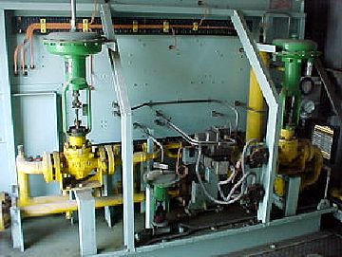

Governor

- Mk2 Unified Governor System
- Electronic, Electro-Hydraulic And Electro Mechanical Units

Combustion Chamber

- Ten Combustion Chamber Fabricated From Nimonic 75 Alloy
- Permit Quick Removal For Inspection
- Lpg Ignition, Simplex Type Burner Nozzle
- Individually Metered And Temperature Monitored.

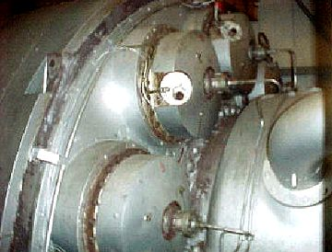

Starter System

- 33 Kv 747kw 1487rpm Induction Starter Motor For Cg1, Cg3 And Cg4
- Turbocharged V Type 1194 Kw/2100 Rpm Diesel Engine Starter For Cg2
- Starter Motor Coupled Through A Torque Converter To The Gas Turbine Rotor
- Fottinger Principal Voith Twin Disc Torque Converter

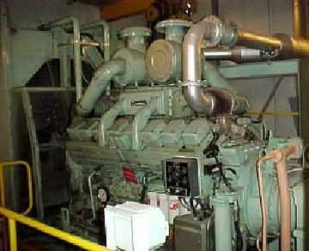

Lubrication And Jacking Oil System

- Mineral Oil Bs489 Grade 46 Total Quantity 200kg
- Shaft Driven Positive Displacement Oil Pump Via Auxiliary Gearbox.
- 1 Ac Motor Centrifugal Oil Pump
- 1 Dc Motor Centrifugal Oil Pump For Emergency Standby
- 2 Ac Motor Jacking Oil Pumps
- 1 Air Oil Cooler And 1 Duplex Strainer

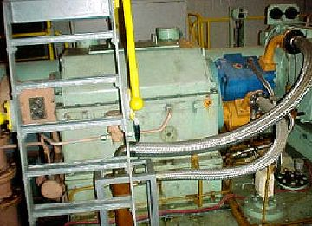

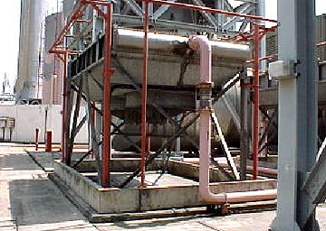

Barring System

- Hydraulic Ratchet Powered By Jacking Oil Pump
- Automatic Timing Control
- Manual Control Provided

Cooling Air And Gland Packing System

- Bled From Compressor Casing, Cooled By Air Blasr Cooler.
- Cool The Turbine Dics, Diaphragms And Stator Rings
- Packing The Turbine And Bearing Blands.

Intake System

- Turbine Intake Filter Package In A Filter House
- Coalescer Safety Pad
- Duracel High Efficiency Filter
- Differential Pressure Switch
- Inlet Silencer
- Stainless Steel Trash Screen Before Turbine Inlet

- Generator Filter Package In A Pair Of Wing Houses
- Dust Louvre Inertial Separator
- Amerkleen Pad

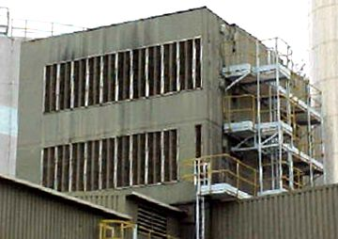

Lagging And Cladding

- Intersperse Acoustic Covers
- Center, Intermediate And Turbine Casing Cladding
- Easy To Remove For Turbine Inspection And Maintenance

Compressed Air System

- 2 Ac Motor Driven, Air Cool, 2 Cylinder Air Compressor
- 1 Air Receiver

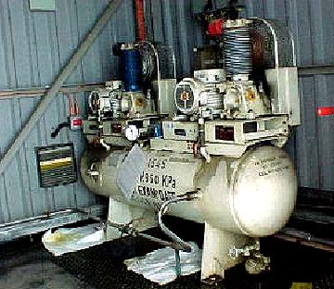

Generator

- 2-Pole, 3 Phase 50 Hz, 11.8kv, 79.4 Mva Air Cooled Generator
- Class F Insulation, Delta Connection
- Temperature Senders At Stator Core, Windings And Air Circuit For Monitoring
- Full Scheme Of Electrical Protection

Exciter

- Revolving Armature Brushless Exciter With Silicon Diodes.
- Directly Coupled To Generator Rotor.
- Static Circuit Avr.
- Manual Follow Up Circuit
- Full Automatic Protective Devises.

Sss (Synochro-Self-Shifting) Clutch (Cg4 And Cg4 Only)

- Installed Between The Gas Turbine And The Generator.
- Fully Automatic, “Freewheel” Devise Transmits Power Through Gear-Tooth Element.
- Permits The Generator To Become A Synchronous Compensator.

Transformer

- Generator Transformer
- Pauwel Trafo 11.8/132kv 80mva Generator Transformer.
- Dy Connection, Ofaf Cooling With On Load Tap Changer.
- Full Scheme Of Electrical Protection.

Unit Transformer

- Woden 11,000/433v 250kva Unit Transformer.
- Dy Connection, Onan Cooling
- Full Scheme Of Electrical Protection.

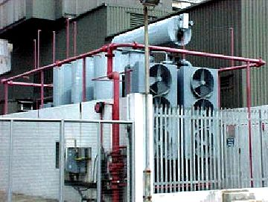

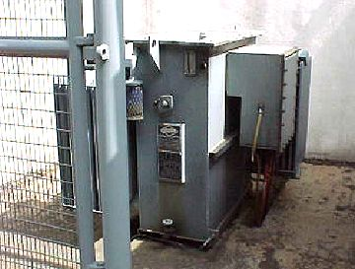

Other Auxiliaries

Inverter
- 110v Ac And Dc Power Supply To Essential Auxiliaries And Controls.
- 56 Hoppecke Battery Cells.

Temperature Monitoring And Data Acquisition System

- High Scanning Speed Digilink 4+ Monitoring System
- Ms Dos Base Data Acquisition Program Kview
- Real Data Color Graphic, Trenching And Event Logging

Control Room Layout

- Ac/Dc Auxiliary Switch Board
- Essential Supply Cubicle
- Duel Battery Charger Cubicle
- Fire Detection And Protection Cubicle
- Control/Extinguishing And Detection Module
- Local Control Panel Suit
- Synchronization, Excitation, Generator Protection Panel.
- Contains All The Necessary Relays And Circuitry
- Governor Panel
- Contains The Mk2 Modular Governor System
- Turbine Control Cubicle
- Auto Start/Run Up Control
- Auxiliaries Control
- Monitoring Equipment Cubicle
- Vibration Monitor
- Turbine Trust Waer Monitor
- Temperature Monitor
- Torch Lit Amplifier
- Dual Flame Detection Module

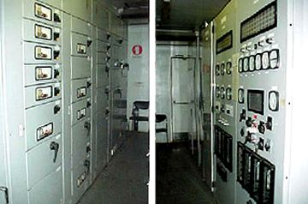

Fire Fighting Equipment

- Alfa-Minerva Automatic Fire Fighting And Detection System.
- Halon System Covers Turbine And Generator
- Enclosure, Control Room, Battery Room And Fuel Annex.
- Water Spray System Protects Generator Transformer, Unit Transformer And Lubrication Oil Cooler.

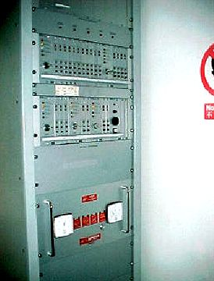

Documentation

- Full Set Of Operation, Maintenance Volumes
- Full Set Of Sub-Contractors Literature.

Turbine And Maintenance Special Tools

- Special Tools Are Available With List.

Turbine And Generator Spares

- Spares Are Available With List.

Options

Diesel Oil Tank
- Two 3,000 Ton Diesel Oil Tanks And Pipework.
- Manual Foam Injection Fire Protection System.

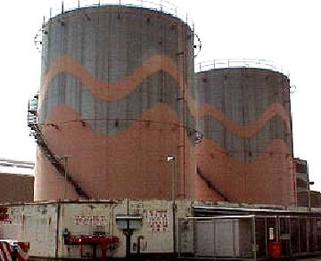

LPG Plant

- One 1,400kg Lpg Storage Vessel And Pipework
- Two Electrical Vaporizers

